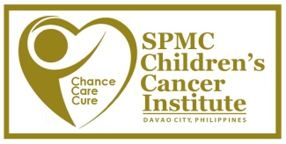
VOLUNTEER APPLICATION FORM

Hospital Volunteer Program is an additional patient care service of Children’s Cancer Institute (CCI) and a joint project of House of Hope Foundation for Kids with Cancer, Inc and Southern Philippines Medical Center. We thank you for volunteering in this program. To complete your application, kindly submit the signed volunteer application form at SPMC- CCI Administration Office.
For questions or clarifications, please contact the administration office at (082) 287 2161 and look for Mr. Khalel or Ms. Janeva.
CONTACT INFORMATION
First Name: | Last Name: |  |  |  | M.I.
Home Address: |  |  | Gender:
Birth Date: |  |  |  | Age:
Email Address: |  | Mobile Number/s:
Employer &Occupation (if applicable):
How did you hear about the volunteer program? (Please be specific)
EMERGENCY CONTACT
Full Name: |  | Phone Number:
VOLUNTEER INTERESTS & EXPERIENCE
Preferred area of service:
___ In-patients
___ Parent Support

Please list any previous volunteer experience (if applicable)
Organization |  | Volunteer Activity

COMMITMENT

I HEREBY STATE THAT I HAVE READ AND UNDERSTOOD HOUSE OF HOPE FOUNDATION FOR KIDS WITH CANCER CODE OF CONDUCT. FURTHERMORE, I COMMIT TO ABIDE BY SUCH CODE OF CONDUCT AS PART OF THE ORGANIZATION AND THEREAFTER.

NAME __________________________
SIGNATURE __________________________
DATE __________________________

______________________________
Signature over printed name & date

